Stat Crunch Project

Student’s Name
Department, University
Course Number and Name
Instructor’s Name
Date

Stat Crunch Project
Locate: Find and list a data set containing at least one quantitative variable – consider a data set from your area of interest.
The dataset selected shows the United States of America’s Education budget as compared to the GDP for the years 1976 through 2016.
Link to dataset: https://datahub.io/core/usa-education-budget-analysis
Data:
YEAR | BUDGET_ON_EDUCATION | GDP | RATIO
1976 | 9314 | 1877587 | 0.496
1977 | 10568 | 2085951 | 0.507
1978 | 11625 | 2356571 | 0.493
1979 | 13996 | 2632143 | 0.532
1980 | 15209 | 2862505 | 0.531
1981 | 16752 | 3210956 | 0.522
1982 | 15374 | 3344991 | 0.46
1983 | 15267 | 3638137 | 0.42
1984 | 15336 | 4040693 | 0.38
1985 | 18952 | 4346734 | 0.436
1986 | 17750 | 4590155 | 0.387
1987 | 19475 | 4870217 | 0.4
1988 | 20098 | 5252629 | 0.383
1989 | 22819 | 5657693 | 0.403
1990 | 24549 | 5979589 | 0.411
1991 | 27360 | 6174043 | 0.443
1992 | 28685 | 6539299 | 0.439
1993 | 31324 | 6878718 | 0.455
1994 | 26881 | 7308755 | 0.368
1995 | 32245 | 7664060 | 0.421
1996 | 29097 | 8100201 | 0.359
1997 | 33519 | 8608515 | 0.389
1998 | 35298 | 9089168 | 0.388
1999 | 33643 | 9660624 | 0.348
2000 | 31816 | 10284779 | 0.309
2001 | 39734 | 10621824 | 0.374
2002 | 55838 | 10977514 | 0.509
2003 | 63001 | 11510670 | 0.547
2004 | 67161 | 12274928 | 0.547
2005 | 74476 | 13093726 | 0.569
2006 | 100019 | 13855888 | 0.722
2007 | 68265 | 14477635 | 0.472
2008 | 65399 | 14718582 | 0.444
2009 | 131891 | 14418739 | 0.915
2010 | 62911 | 14964372 | 0.42
2011 | 43628 | 15517926 | 0.281
2012 | 57458 | 16155255 | 0.356
2013 | 39495 | 16691517 | 0.237
2014 | 55200 | 17393103 | 0.317
2015 | 87258 | 18120714 | 0.482
2016 | 76977 | 18624475 | 0.413

Identify: Identify the quantitative variable from your data set that you are interested in describing (Example: age, income, height, price, etc.)
All of the three variables: GDP, Budget on education, and the ratio of both are quantitative. The variable of interest which will be analyzed is “ratio”. Analyzing this variable is a more objective way of analyzing the education budget throughout the years (Datopian, n.d.).

Evaluate: Explain why one should think that your data are credible, reliable, and current. (If you decide that the source is not credible, you may still use it for the purposes of this assignment.)
The data set was obtained through https://datahub.io, however, the original dataset comes from Office of Management and Budget from the White House official website, making it a credible and reliable dataset (Datopian, n.d.).
Since the years in the dataset are up to 2016, which is only four years ago, the dataset is also current.

Incorporate: Provide one graphical summary of your quantitative variable and identify the most appropriate measure of center based upon the shape of your distribution. Justify your reasoning.
Using StatCrunch a scatter plot was constructed plotting the ratio of education budget (to GDP against time (years). This graphical summary was selected because it will help us analyze how the ratio changes over time.
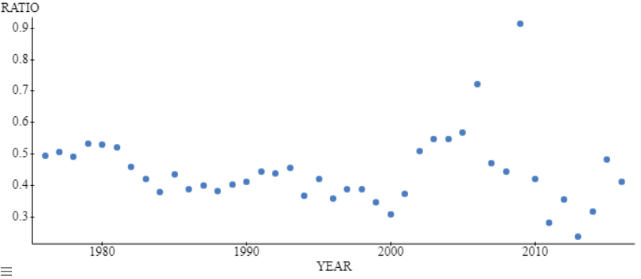
The most appropriate measure of center is the median. This is because we can see two outliers in the scatter plot, this will affect the calculation of the mean but will not affect the median.
Responsible Use: Cite the source of your data using the APA format. (See page 188, #48, in your textbook for an example of an APA citation.)

References
Datopian. (n.d.). United States of America education budget analysis. Retrieved February 20, 2021, from https://datahub.io/core/usa-education-budget-analysis#readme

